**All Spool Data**

Setup.txt

OpenPO.txt

ReceivePO.txt

QueryPO.txt

Aging.txt

Shortship.txt

SupplierMonthly.txt

TableStructure.txt

TestData.txt

OpenPO.txt

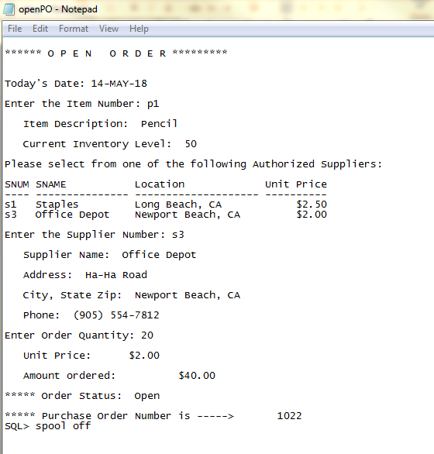

ReceivePO.txt

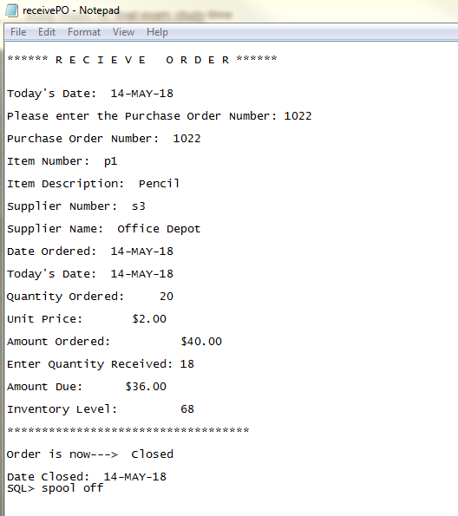

QueryPO.txt

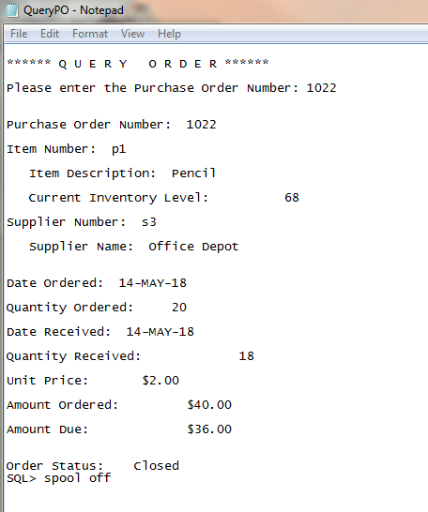

Aging.txt

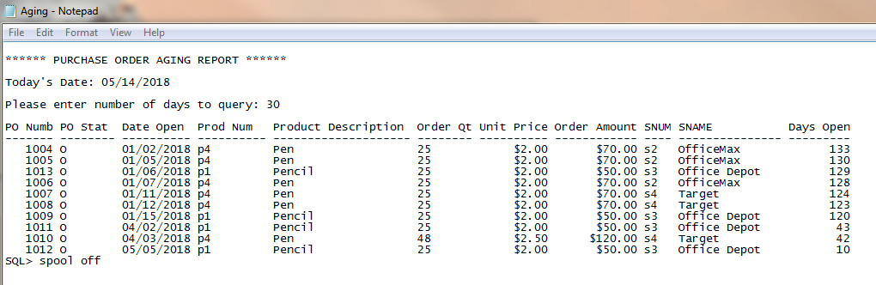

ShortShip.txt

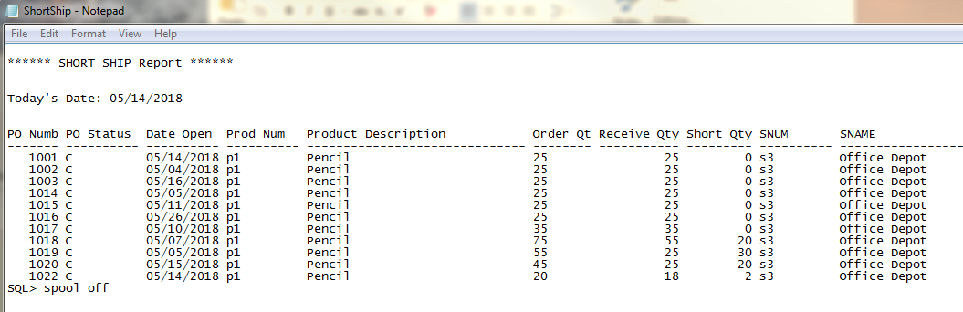

SupplierMonthly.txt

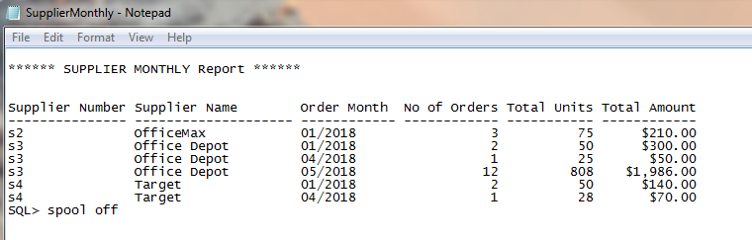

TableStructure.txt

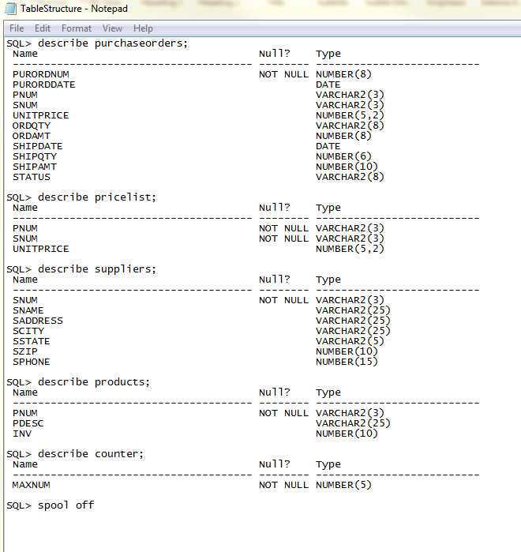

TestData.txt

